UID EXP 6 – QR Based Parking System
Introduction
QR Based Parking System is a smart parking solution where users can scan a QR code to enter/exit parking, check slot availability, and make payments digitally.
It reduces manual work, saves time, and improves parking efficiency.
Key Characteristics of RAD
• Focus on prototype development
• Continuous user feedback
• Fast development and iteration
• Reusable UI components
• Suitable for mobile/web applications
Phase 1: Requirements Planning
This phase identifies system requirements and user needs.
Features:
Navigation:
• Home
• Parking Slots
• QR Scan
• Payment
• Booking History
User Actions:
• View available parking slots
• Scan QR code to enter parking
• Book slot
• Make payment
• Exit using QR
• View history
Requirements:
- Display available parking slots
- Allow users to scan QR code
- Show booking details
- Enable online payment
- Track entry and exit time
- Generate confirmation message
Phase 2: User Design
Wireframes and UI prototypes are created.
Tools Used:
• Figma / Canva
Designed Screens:
• Home Page – Shows parking availability
• Slot Selection Page – Choose parking slot
• QR Scanner Page – Scan entry QR
• Booking Confirmation Page
• Payment Page
• Exit Screen (QR scan)
• History Page
Design Features:
• Simple and user-friendly interface
• Clear navigation between screens
• Reusable components like header/footer
• Buttons for scan, book, and pay
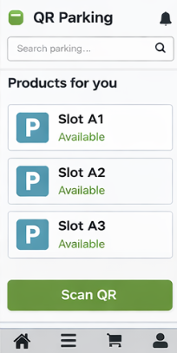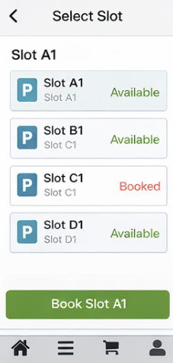
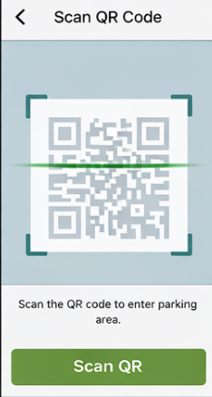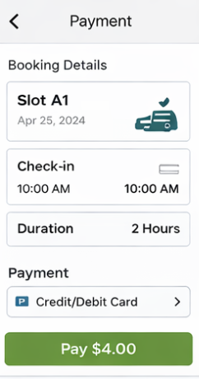

Phase 3: Construction
Development and testing happen simultaneously.
Prototype Flow:
Home → Slot Selection → QR Scan → Booking → Payment → Confirmation → Exit
Dynamic Features:
• QR scanning simulation
• Slot availability updates
• Payment processing screen
Testing:
• Prototype tested using preview mode
• Feedback collected from users
• UI improved based on suggestions
Phase 4: Cutover
Final stage where system is ready for deployment.
Finalization:
• Prototype shared via Figma link
• Ready for development
• Can be converted to real app
User Support:
• User instructions provided
• Easy navigation for all users
• Documentation shared

Conclusion
The QR Based Parking System improves parking management by reducing time, avoiding congestion, and enabling digital transactions, making it efficient and user-friendly.
